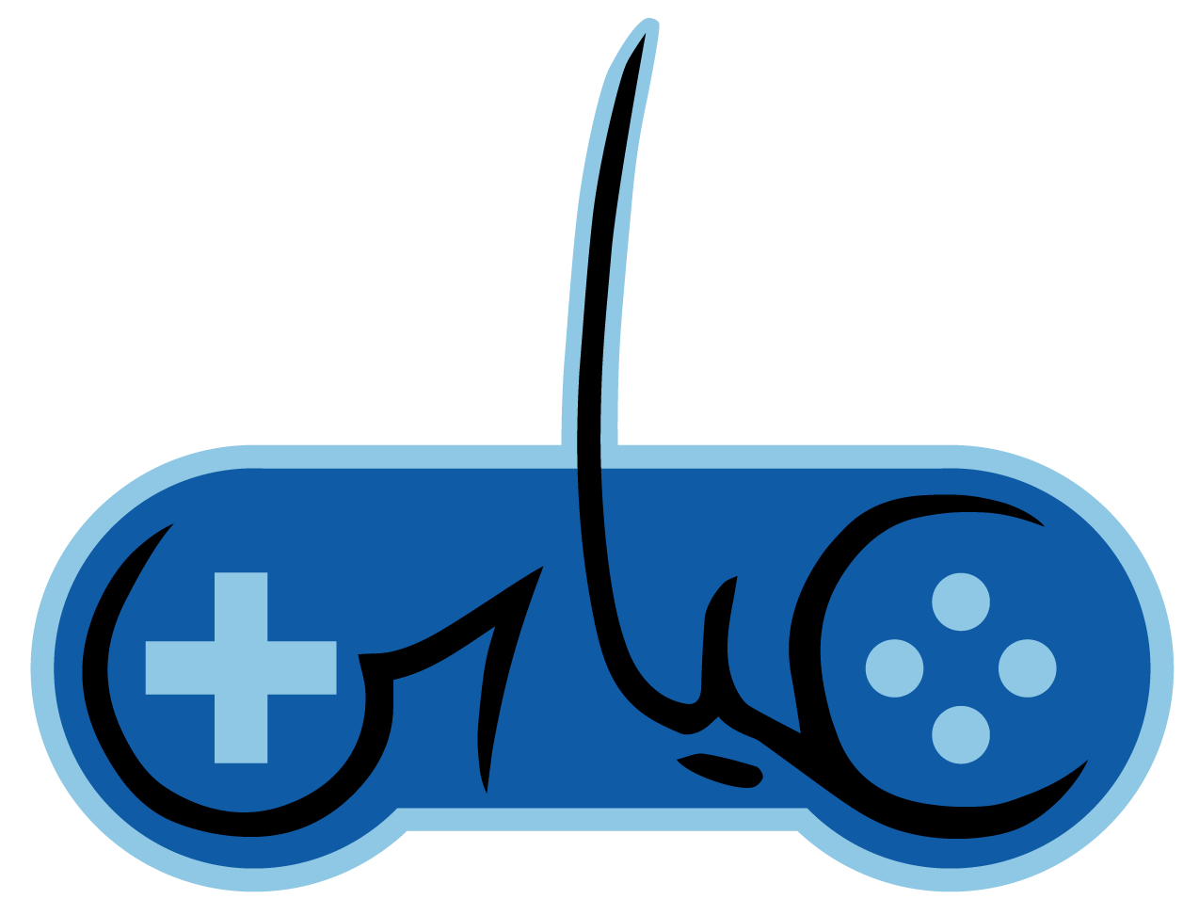
Abbas Boumelhem | Unity Engineer | Game Designer
Boumelhem.Abbas@Gmail.com
AbbasBGames.com

Unity C# Engineer with 8+ years of experience.
My primary motivations are making projects feel great to play and prioritizing where I need to make things work to bring projects across the finish line.

Skills:
Game Development  Unity Engine  C# Programming  2D/3D tech art | 3D Software  Blender  3DS Max  Quixel | Other Software  Photoshop  Wwise | Languages  English  Spanish  Arabic

Work Experience:

Dream Toaster Games | Unity Developer | Contract, Gearbox Software | 01/2025 - Present
- Risk of Rain 2 | Game Design | Gameplay Programming
- Contracted with Gearbox Software to support development of Risk of Rain 2: Alloyed Collective DLC.
- Able to switch priorities as development was needed between Enemies, Playable Characters, and Bosses, including the Final Boss.
- Hashed out improved design with designers, implemented and adjusted gameplay based on feedback.

Absolute Games, Penn Interactive | Unity Engineer | Full-Time | 08/2018 - 06/2025
- Absolute Bingo | Mobile Unity Development | Game Design | 2D Tech Art | UI
- Updated UI in the Unity UI system with new given art, polishing the feel and visuals
- Iterated existing, and designed new minigames using Unity UI to keep players engaged
- Viva Slots Vegas | Mobile Unity Development | 2D Tech Art | UI
- Helped recreate broken game almost entirely from scratch, re-developing existing features to run better, but to be invisible to the large existing userbase to ensure a smooth transition
- Worked closely with art to improve visuals, while developing pipelines for bringing their art in Unity

Tap Slots | Unity Engineer| Intern | 03/2018 - 12/2018
- Vegas Slots Cherry Master | Mobile Unity Development | 2D Tech Art
- Developed the Puzzle feature from given prototype, polishing gameplay feel and implementing art

Global Genesis Group | Game Programmer | Intern | 05/2016 - 03/2017
- Escape Room the Movie Game | Mobile Unity Development | 2D Tech Art
- Worked with self-starters and built a tie-in mobile game to promote the movie Escape Room (2017).

Personal Projects
- Wizard Game | Game Design | Gameplay Programming | 3D Tech Art
- Developed a Unity component object-oriented architecture for very modular characters
- Designed from scratch complex gameplay mechanics
- Red Alert | Modding | Game Design | Gameplay Programming | Editor Scripting | 3D Tech Art | Sound Design
- Designed and developed unique new mechanics, while fitting and being balanced to the base game
- Full pipeline for bringing 3D modeled, rigged, textured, and animated characters into Unity
- Joe and the Zambambos | Gameplay Programming | Character 3D Modeling | Rigging | Animation
- Modeled, rigged, animated the main character, and polished combat feel
- Castle Hamson Tribute | Procedural Generation | Editor Scripting | Modeling | PBR Texturing
- Developed procedural generation of rooms made with modular pieces that I modeled and textured.

The Art Institute of Las Vegas | Education| 06/2013 - 12/2017
- Bachelor of Science: Game Art and Design

